Burkina Faso

## GNI per capita and development level

The data set shows the GNI per capita and development level of the country each year.

## # A tibble: 19 x 5  
## country iso3c date GNIperCapita devCategory  
## <chr> <chr> <dbl> <dbl> <chr>   
## 1 Burkina Faso BFA 1996 440. Low Income   
## 2 Burkina Faso BFA 1998 473. Low Income   
## 3 Burkina Faso BFA 2000 488. Low Income   
## 4 Burkina Faso BFA 2002 509. Low Income   
## 5 Burkina Faso BFA 2003 532. Low Income   
## 6 Burkina Faso BFA 2004 542. Low Income   
## 7 Burkina Faso BFA 2005 570. Low Income   
## 8 Burkina Faso BFA 2006 592. Low Income   
## 9 Burkina Faso BFA 2007 598. Low Income   
## 10 Burkina Faso BFA 2008 614. Low Income   
## 11 Burkina Faso BFA 2009 608. Low Income   
## 12 Burkina Faso BFA 2010 628. Low Income   
## 13 Burkina Faso BFA 2011 643. Low Income   
## 14 Burkina Faso BFA 2012 674. Low Income   
## 15 Burkina Faso BFA 2013 691. Low Income   
## 16 Burkina Faso BFA 2014 689. Low Income   
## 17 Burkina Faso BFA 2015 693. Low Income   
## 18 Burkina Faso BFA 2016 713. Low Income   
## 19 Burkina Faso BFA 2017 741. Low Income

## GDP growth and economic growth classification

The data set shows the GDP growth and the ecomic growth classification of the country each year.

## # A tibble: 19 x 5  
## country iso3c date GDPannualGrowthRate GDPgrowthCategory4  
## <chr> <chr> <dbl> <dbl> <fct>   
## 1 Burkina Faso BFA 1996 11.0 fast growth   
## 2 Burkina Faso BFA 1998 7.31 fast growth   
## 3 Burkina Faso BFA 2000 1.89 slow growth   
## 4 Burkina Faso BFA 2002 4.35 moderate growth   
## 5 Burkina Faso BFA 2003 7.80 fast growth   
## 6 Burkina Faso BFA 2004 4.48 moderate growth   
## 7 Burkina Faso BFA 2005 8.66 fast growth   
## 8 Burkina Faso BFA 2006 6.25 fast growth   
## 9 Burkina Faso BFA 2007 4.11 moderate growth   
## 10 Burkina Faso BFA 2008 5.80 fast growth   
## 11 Burkina Faso BFA 2009 2.96 moderate growth   
## 12 Burkina Faso BFA 2010 8.45 fast growth   
## 13 Burkina Faso BFA 2011 6.62 fast growth   
## 14 Burkina Faso BFA 2012 6.45 fast growth   
## 15 Burkina Faso BFA 2013 5.79 fast growth   
## 16 Burkina Faso BFA 2014 4.33 moderate growth   
## 17 Burkina Faso BFA 2015 3.92 moderate growth   
## 18 Burkina Faso BFA 2016 5.96 fast growth   
## 19 Burkina Faso BFA 2017 6.20 fast growth

## Development trend

The plot shows the development trend of the country.

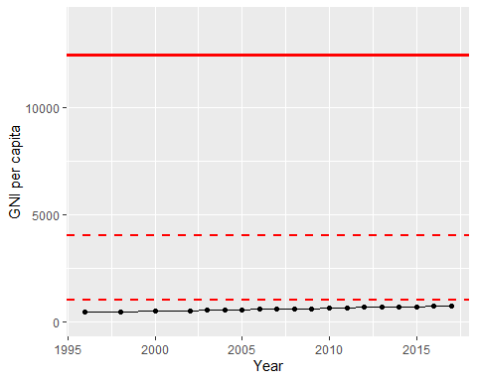

GNI Per Capita Trend